6. Convert an Image to Erode Using the Erode Function in Python
Aim: To read an image in Python and perform image erosion using the OpenCV erode() function.
Procedure
- Import the OpenCV library.
- Read the input image.
- Create a kernel for erosion.
- Apply the cv2.erode() function to the image.
- Display the original and eroded images.
Code
import cv2
import numpy as np

img = cv2.imread("sample.jpg")

if img is not None:
kernel = np.ones((5, 5), np.uint8)
eroded = cv2.erode(img, kernel, iterations=1)

cv2.imshow("Original Image", img)
cv2.imshow("Eroded Image", eroded)

cv2.waitKey(0)
cv2.destroyAllWindows()
else:
print("Image not found")
Input
An image named sample.jpg saved in the same folder as the Python program.
Output
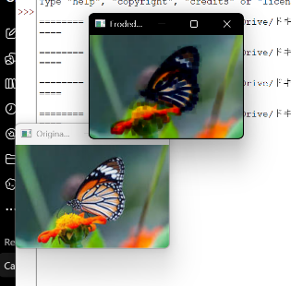
Result
The input image was successfully read and processed using the OpenCV erode() function to perform image erosion.

